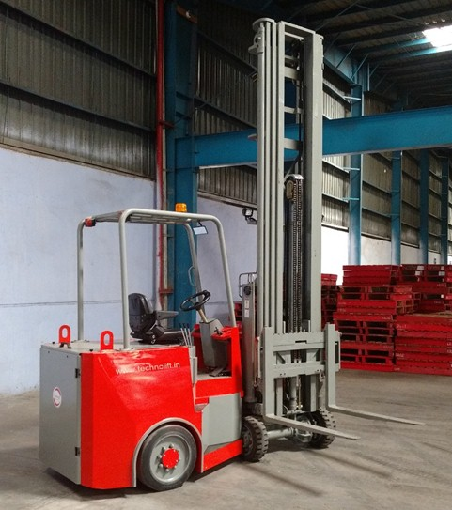

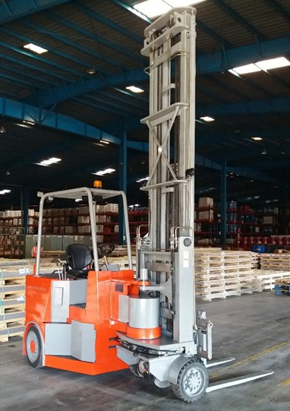

ARTICULATED MAST FORKLIFT - TECHNICAL SPECS SHEET
Sr. No. | Description | Unit | Specification
1 | Model |  | TAMF1890
2 | Capacity | Kgs | 1800
3 | Capacity @ 9 mtr | Kgs | 800
4 | Load Center | mm | 500
5 | Steering Type |  | Power
6 | Lift height | mm | 9000
7 | Free Lift Height | mm | 3150
8 | Height Mast Closed | mm | 4000
10 | Height Mast Extended | mm | 9900
9 | Overall length | mm | 4090
11 | Ground Clearance (Chassis / Mast) | mm | 80 / 100
12 | Overhead Guard Height | mm | 2200
13 | Overall Width | mm | 1400
14 | Fork | mm | 1050 X 80 X 45
15 | Seat Height | mm | 1275
16 | Carriage Tilt (Back/Forward) | Deg | 1⁰ / 2⁰
17 | Lift speed (Unladen/Laden) | mpm | 15 / 13
18 | Ground Speed | Kmph | 41924
19 | Gradeability (Laden/Unladen) |  | 01:08
20 | Rear tyre size | mm | 535X175
21 | Front tyre size | mm | 457X175
22 | Battery voltage | V | 48
23 | Battery capacity (ah) | Ah | 630
24 | Standard Colour |  | Red
25 | Drive Motor - AC | Kw | 11
26 | Hydraulic Motor - AC | Kw | 15
27 | Service Brake |  | Hydraulic
28 | Parking Brake |  | Mechanical


